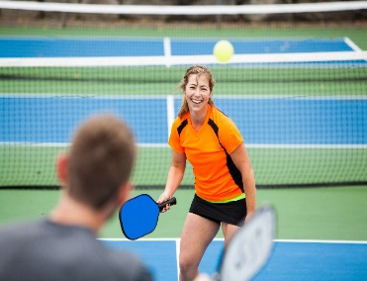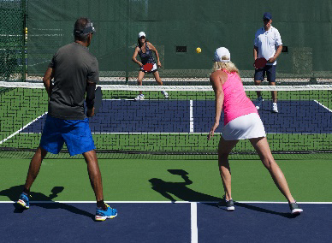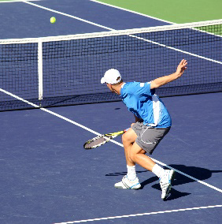

A.Y.T.E. League Rules
Please join the league if you are committed to scheduling and playing 5-10 matches.
Rules of Tennis and Pickleball and The Code for Unofficiated Matches apply through the USTA and USAPA. Coaching is not allowed in AYTE League matches.
Players must be age 16 or over in this calendar year and willing to play the league within the defined area. Players under 16 have to play in our Junior League.
Ratings
Players with current NTRP Ratings in Tennis Link must use that rating and the same for USAPA. They may play no more than 0.5 above their rating level and may not play below their level. Players without ratings must self-rate according to the NTRP/USAPA guidelines.
AYTE does not accept NTRP/USAPA related grievances. Players are expected to exercise the highest level of integrity while competing in this program.
Match Scoring
A round robin format is used with one match assigned per week. One to two additional weeks are included at the end of the season to make up missed matches.
Scoring format is best 2 of 3 regular scoring 6 games set, regular tiebreaker at 6 games all for Tennis and best 2 of 3, 11 point set for Pickleball win by 1. Top two players/teams in each flight will advance into the playoffs. Number of flights are determined by number of entries. Please report all scores by emailing Hai Nguyen at playtennisca@gmail.com at the conclusion of your matches. Results and standings will be updated each week and can be viewed on our website at www.ayte.co
Scheduling
AYTE League uses 'play by' dates to encourage players to schedule weekly matches. Matches can be played at any time*, in any order, as long as they are completed by the season deadline. *Daytime only flights must play matches on weekdays (M-F) between the hours of 9am and 3pm, unless otherwise agree on by players.
Players or teams are encouraged to make contact. It’s recommended to contact all opponents at the beginning of the season to start the scheduling dialog. Some player’s schedules are more compatible than others. Schedule and play the most convenient matches first. In order to encourage more play, we now have a policy on communication responsibilities.
Acknowledge your opponent’s calls or emails even if you're unavailable to play. If you're leaving town, let your opponents know that you'll contact them when you return. If your opponent tries you three times (2 via email and 1 via phone) and does not receive acknowledgement, she can report your lack of response and take a default win.
Both Players should bring a new can of balls, open one can, the winner takes the new unopened can. The date, time and location of the match must be agreed upon by all players.
If a match is rained out, it should be rescheduled and completed as soon as possible.
Awards
Flight winners will be determined by the standings on the last day of the season. In the event of a tie, head to head competition will determine the winner followed by % of sets won and then % of games won. Trophies to Champions and Finalists will be awarded in Tennis for each Division. Medals(Gold, Silver, and Bronze) will be awarded to top three teams in pickleball in each Division.
Defaults
Within 24 hours of the agreed match time, the player or team unable to play will default the match unless the player receiving the default prefers to reschedule the match.
If a player does not arrive within 15 minutes of the scheduled time, that player will default the match unless the opponent agrees to extend the time or reschedule the match.
Defaults can greatly impact standings in many ways but are sometimes unavoidable. Defaults will be scored as a 6-0, 6-0(tennis) or 11-0, 11-0 win for the player/team receiving the default. Excessive defaults by players who do not withdraw will be monitored for future seasons.
Lack of communication is another method by which a player can earn a default. If you are unable to make contact with your opponent after 3 tries (2 via email and 1 by phone)
1.Report the incident and
2.Take a default win
If your opponent communicates after you’ve taken steps 1 and 2 that she would like to play, it is your choice to reinstate the match. Contact your administrator to reset the match.
After three reports from that a player is non-responsive, player will be contacted, matches scored as defaults, and player suspended from playing the next season.

Withdrawing from the League
In the event that a player must withdraw from the league prior to completing the schedule, he/she should notify the administrator and her/his opponents.
If a player withdraws prior to playing a match, all of his/her matches will simply be deleted.
If a player withdraws in the flight after playing a match, all players in the group will receive a 6-0, 6-0 or 11-0, 11-0 win against the withdrawing player. This rule attempts to give credit to players who have already played a withdrawing player without penalizing those players who did not play the withdrawing player.
The administrator will attempt to replace a player who withdraws with a substitute for the remainder of the season.
No refunds will be issued once schedules have been posted.
Sportsmanship Policy
All players participating in AYTE League, as a condition of said participation, agree to abide by and be bound by the “The Code”: a Players’ Guide to Fair Play and Sportsmanship. Tennis and Pickleball are games of courtesy and honor. We expect the highest level of sportsmanship on and off the court. Players who repeatedly hinder the enjoyment of the game will be warned then suspended from the league.
Please report unsportsmanlike conduct to playtennisca@gmail.com as soon as possible. First offenses will be logged, second offenses earn a warning via phone, and third offenses result in suspension from the current season and the one following. No refunds will be offered.
What constitutes an offense will be deliberated on a case- by-case basis and at the sole discretion of the AYTE League administrator. Players who return after suspension are subject to a no-tolerance policy. Any further complaints on such players are grounds for permanent suspension from the league.
Liability
WAIVER, RELEASE AND ASSUMPTION OF RISK: In consideration of your participation in the AYTE Leagues, you hereby waive, release and discharge all claims for damages for death, personal injury, or property damage which may occur as a result of my participation in the tennis and pickleball league or any activity incident thereto. This release discharges in advance AYTE, its officers, agents, servants, and employees, game officials and referees (hereinafter referred to collectively as “AYTE”) from liability even though that liability may arise out of AYTE’S active or passive negligence or carelessness. I acknowledge that some recreational activities, including tennis and pickleball, involve an element of risk or danger of accidents, injury and even death, and knowing those risks, I freely and voluntarily assume the risk of injury and/or death and I promise not to sue or exercise any legal right to seek damages from AYTE. By this Agreement, I also intend to waive, release and discharge all claims for personal injury, death or property damage caused by the condition of the tennis or pickleball court or any equipment thereon, nets, net posts, balls.
I understand that this WAIVER, RELEASE and ASSUMPTION OF RISK form will remain on file with AYTE and that it will apply to the current season as well as my participation in future seasons in AYTE Leagues.
I certify that I have no medical condition that would cause participation in the basketball leagues to increase the risk of hazard to my health. In addition, I authorize AYTE to provide or cause to be provided such medical treatment that may be necessary or appropriate if I am injured while participating in the tennis or pickleball league.
Player’s Name______________________________ Signature____________________________
(If minor under 18, please have parent sign)

